By [Bob Petz](http://www.ecology.com/author/bob-p/), August 27, 2012

*Visualization above shows the extent of Arctic sea ice on Aug. 26, 2012 -- the smallest in more than three decades of satellite measurements. The outline indicates average minimum extent during 1979-2010 as measured by satellites. Source: NASA and the National Snow and Ice Data Center*

The extent of sea ice covering the Arctic Ocean this month shrunk to its smallest area in the three decades since satellite observations of the polar cap began.

Arctic sea ice on August 26, measured 1.58 million square miles (4.1 million sq km), or 27,000 sq mi (70,000 sq km) below the previous record low of 1.61 million sq mi (4.17 million sq km) set on September 18, 2007. And this year’s melt season isn’t over.

The sea ice cap naturally grows during the cold Arctic winters and shrinks when temperatures climb in the spring and summer. But over the last three decades, satellites have observed a 13 percent decline per decade in the minimum summertime extent of the sea ice.

The thickness of the sea ice cover also continues to decline.

“The persistent loss of perennial ice cover — ice that survives the melt season — led to this year’s record summertime retreat,” said Joey Comiso, senior research scientist at NASA’s Goddard Space Flight Center in Greenbelt, Md. “Unlike 2007, temperatures were not unusually warm in the Arctic this summer.”

The new record was reached before the end of the melt season in the Arctic, which usually takes place in mid- to late-September. Scientists expect to see an even larger loss of sea ice in the coming weeks.

“In 2007, it was actually much warmer,” Comiso said. “We are losing the thick component of the ice cover. And if you lose the thick component of the ice cover, the ice in the summer becomes very vulnerable.”

[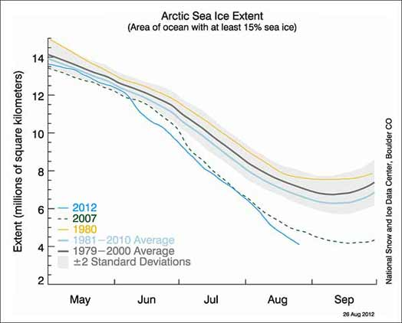](http://www.ecology.com/wp-content/uploads/2012/08/arctic-sea-ice-extent-524.jpg)

According to NSIDC Director Mark Serreze, “The previous record, set in 2007, occurred because of near perfect summer weather for melting ice. Apart from one big storm in early August, weather patterns this year were unremarkable. The ice is so thin and weak now, it doesn’t matter how the winds blow.”

“The Arctic used to be dominated by multiyear ice, or ice that stayed around for several years,” Meier said. “Now it’s becoming more of a seasonal ice cover and large areas are now prone to melting out in summer.”

Including this year, the six lowest ice extents in the satellite record have occurred in the last six years (2007 to 2012).

A full analysis of the 2012 melt season will be published in early October.